本试卷适用范围 | 南京农业大学试题  试卷类型：（A）
  大二ESP
  商务英语Unit1-4
课程 商务英语 学号 姓名 成绩
Part I. Listening Comprehension (30 points)
A. Listen to each conversation for two times and fill in blanks with the exact words. (25 points)
Conversation 1:
Emily: … so you’re saying that if this project goes wrong, there’s a real risk of the company 1)_____________?
Frank: If we make a big loss, and the investors find out, our share price in Wall Street will be 2)_____________.
Emily: But why should we 3)_____________? The project is going well, isn’t it?
Frank: Ok, maybe 4) ______________ is a little strong, but I’m worried about the project 5)________________. There is too much money going out and not enough coming in. Like just the day before he killed himself, Sean came to me and said that Filippo wanted us to just 6)____________ some debt from a local company. They borrowed some money from us to buy some equipment which we then said we didn’t need, and Sean and Filippo claimed they couldn’t pay us back. I mean … big deal … so what … is that my problem? I just want you to have a good look at the books and make sure this project is completely 7)_______________ so we have a nice clean 8)_______________ without too many liabilities at the end of the year. And, maybe keep an eye on Filippo…
Emily: What, him and Sean …? No! Do you think…?
Conversation 2:
Neill: So … good to see you all, ladies and gentlemen. Right, 9)___________________________.
Got your pen, Julie? 10)_____________________________? Great … oh… and coffee?
Julie: Simon’s bring it in later, if that’s OK with you.
Neill: Ok. That’s a good idea. Just one point on the agenda today --- the new product launch. Tim, you’re in charge of that. 11)________________________________________?
Tim: Right, well, we’ve booked the Hotel Orient conference room for the 22nd from 8 am until midnight. We’ve agreed…
Chris: Sorry, 12)________________________________? Did you say the Orient?
Tim: Er, yes…
Chris: 13)_______________________! It hasn’t got any atmosphere. I think we should use the Shangri La as we did before. 14)__________________________, Neil?
Neill: 15)_________________________, Chris. Anyway, after what you said to the manager last year, they told us never to come back.
Chris: 16)________________________________? All I said was …
Neill: 17)________________________. I don’t think Julie, or anyone here, wants to know what you said … So, carry on please, Tim.
Tim: OK … 18)______________________________ ---food. We’ve arranged lunch for …
(much much later)
Tim: … and is inside the budget. So, 19) _______________________________?
Neill: Yeah, yeah, I think that’s fine. Well done, Tim, Ok… 20)___________________________. And Julie, could you clear the coffee cups? I’ve got another meeting in half an hour … OK, ciao, ciao…
Julie: … one day … I’m going to…
Conversation 3:
Bob: … and now business Watchdog, our weekly look at anything 21)___________ in the world of international business. Tyra Belloni has been 22)_____________ the situation at the global construction company Bergerbild.
Tyra: Thanks, Bob. Bergerbild is building a metro system in Malaysia, and according to my sources there are 23)____________ reasons for thinking that a scandal is about to blow open a story about subcontractors having to pay money to win contracts. The project’s commercial manager killed himself in his hotel room in unusual circumstances in May. No one is quite sure what will happen next, but the 24)___________ from Bergerbild insiders are that at a board meeting tomorrow company auditor Emily Lee will prove he was forcing the subcontractors to pay large sums of money to a charity he ran in Malaysia. There are many 25)___________ grounds for believing that no one apart from this manager and another associate benefited from this charity. We’ll bring you more on this story next week.

B. Directions: Listen to the discussion and match the parts of a contract to the definitions. (5 points)
______ 1. clause
______ 2. appendix
______ 3. sentence
______ 4. section
______ 5. definitions
a. a list of how specific terminology is to be used
b. a part of a contract that normally covers one topic, and contains different clauses or paragraphs
c. a part of a section that gives details about one aspect of a topic
d. a group of words that contains a subject and a verb, and that expresses a complete idea
e. additional information at the end of the contract

Part II. Vocabulary (21 points)
A. What does each Acronym stand for? (5 points)
1.CFO
2.AG
3. CEO
4.PA
5. B/S

B. Explain the following items in English. (10 points)
1. invoice

2. liquidity

3. ledger

4. overheads

5. assets

C. When talking about project management, people prefer to use a triangle to stand for three critical elements. Do you know what they are? （6 points）

( )

（ ） （ ）

Part III. Culture and Communication: Write the names of the countries which are marked with letters in the given map. (12 points)
1. ____________________ 2.__________________ 3. __________________
4. ____________________ 5.__________________ 6. __________________
7. ____________________ 8.__________________ 9. __________________
10. ____________________ 11.__________________ 12. __________________

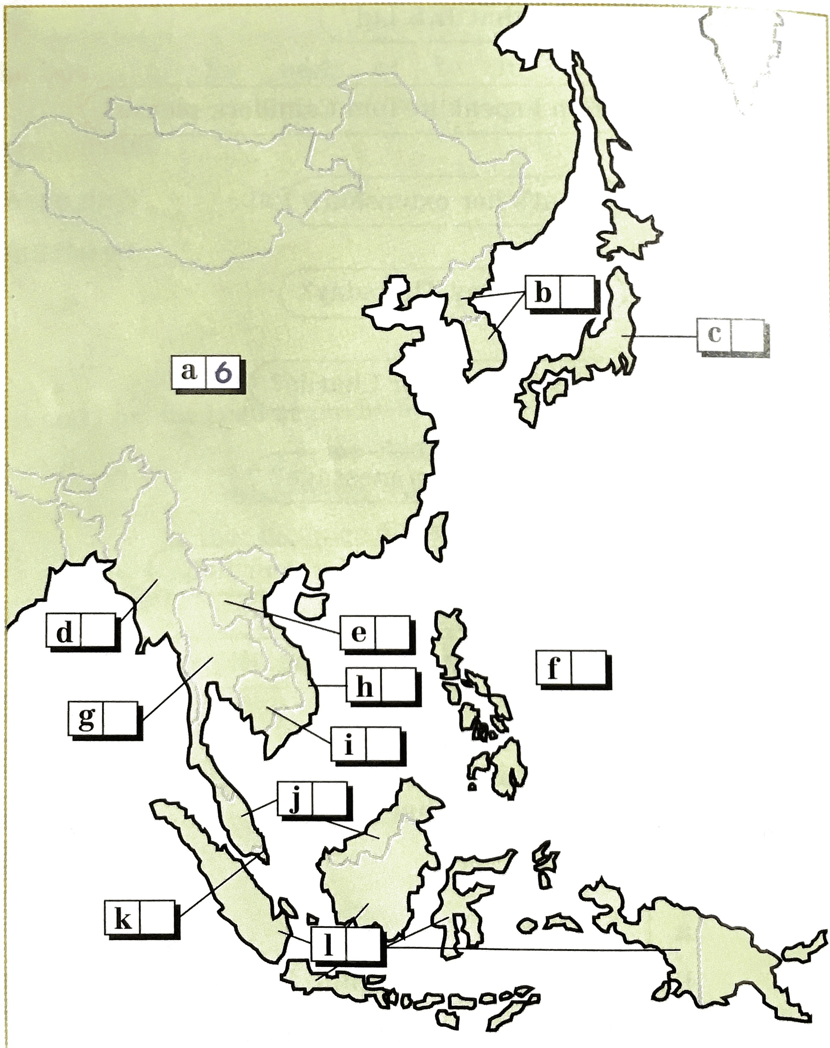

Part IV. Critical Path Method (15 points)
1. Read the given Gantt Charts and draw a diagram based on the information shown in it. Your diagram should show ES, EF, LS, LF and SL for each activity. (10 points)
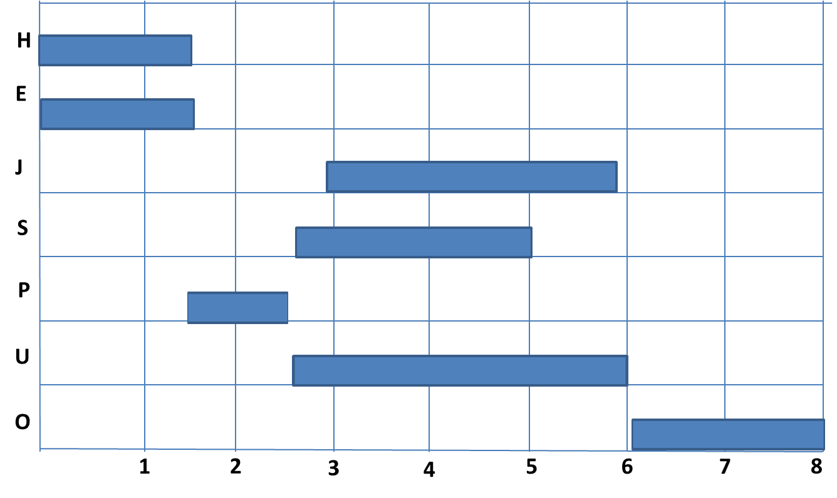( in month)

2. Questions (5 points)
1) What is the critical path for the project?

2) What is the duration of the whole project?

3) Which activities are paralleled activities?

4) For Activity P, which activities are its preceding activities? And which activities are its succeeding activities?

5) Which activities have slack time? And in order not to influence the duration of the whole project, how long should each slack time be?

Part VI. Reading and Writing (22 points)
Emily Lee, from the construction company Bergerbild, is investigating the death of a colleague, Sean McCabe. She has found some strange figures in the accounts of the Kuching Metro project, which Sean was involved with. Filippo is one the project managers. So Emily wants to get some useful information from him, but they two had a very unhappy meeting. Filippo believes Emily’s report will be biased against him and Frank, Emily’s ex-boyfriend, wants him to take the blame, so he is very aggressive and not cooperative at all. Emily was irritated by him in the meeting, and said rudely that if Filippo wanted her report to be a balanced one, he’d better think carefully before opening his mouth.
1. Writes to Frank an email to complain about Emily in the name of Filippo.

2. Emily still needs Filippo’s help, so she decides to write an email of apology to Filippo. Her email might be:

3. Receiving Emily’s email, Filippo decides to apologize as well. His email might be:

